Behavioral Analytics Study of Consumer Purchase Decisions: Evaluating the Impact of Psychological Marketing Nudges Using Python, SQL and Power BI

CHAPTER 1 — INTRODUCTION

1.1 Background
In today's highly competitive e-commerce landscape, businesses continuously seek innovative strategies to influence consumer purchasing decisions and improve conversion rates. Beyond traditional pricing and promotional techniques, organizations increasingly rely on principles from behavioural psychology and behavioural economics to shape customer decision-making. Marketing interventions such as scarcity messages, countdown timers, free shipping offers, recommendation labels, trending badges, and influencer campaigns are designed to leverage cognitive biases and psychological triggers that subtly encourage consumers to complete purchases.
These behavioural interventions influence consumer perception by creating urgency, reducing decision uncertainty, increasing perceived value, or encouraging conformity through social proof. While these techniques are widely adopted across online shopping platforms, understanding which interventions genuinely improve customer conversion and how different customer segments respond remains an important analytical challenge.
Behavioural analytics combines data analysis with behavioural science to study these purchasing patterns and evaluate the effectiveness of various psychological marketing strategies. By analysing customer interactions, businesses can make evidence-based decisions regarding promotional campaigns, personalization strategies, and customer targeting rather than relying solely on intuition.
This study applies behavioural analytics techniques to investigate consumer purchasing behaviour using a synthetic e-commerce dataset. Python was used for data generation and preprocessing, SQL was employed for analytical investigation, and Microsoft Power BI was utilized to present interactive business intelligence dashboards. The study aims to bridge concepts from behavioural psychology with modern data analytics to identify actionable marketing insights.

1.2 Problem Statement
Modern e-commerce platforms employ numerous psychological marketing techniques to influence purchasing behaviour. However, determining the actual effectiveness of these behavioural nudges requires meticulous systematic analysis rather than assumptions.
Businesses often invest in urgency messages, promotional discounts, recommendation systems, and social influence campaigns without fully understanding which interventions generate the highest conversion rates, reduce customer decision time, or perform better across different customer segments.
This study addresses this challenge by analysing customer purchase behaviour through behavioural analytics. The project investigates the impact of multiple psychological nudges on purchase conversion, decision-making speed, and customer responsiveness across demographic and behavioural segments. The findings provide evidence-based insights that can assist businesses in optimizing digital marketing strategies.

1.3 Objectives
The primary objectives of this study are:
- To analyse overall consumer purchasing behaviour and conversion patterns.
- To evaluate the effectiveness of various psychological marketing nudges on purchase decisions.
- To measure the impact of behavioural interventions on customer decision-making time.
- To compare customer responses across demographic and behavioural segments such as age group, income level, loyalty membership, and customer tenure.
- To identify the most effective psychological trigger in improving purchase conversion.
- To demonstrate the application of advanced SQL analytical techniques including CTEs, window functions, views, stored procedures, user-defined functions, and indexing.
- To develop an interactive Power BI dashboard for visualizing behavioural insights and supporting business decision-making.

1.4 Project Workflow Overview
The project follows a structured behavioural analytics workflow, beginning with the creation and preparation of a synthetic e-commerce dataset using Python. The dataset was designed to simulate realistic online shopping behaviour, incorporating customer demographics, purchasing patterns, pricing information, and multiple psychological marketing nudges.
The prepared dataset was then imported into MySQL, where advanced SQL techniques were employed to investigate consumer behaviour, evaluate the effectiveness of behavioural interventions, measure conversion lift, analyse customer responsiveness across different segments, and identify key behavioural patterns.
Finally, the analytical findings were transformed into interactive Power BI dashboards, enabling the visualization of customer behaviour, marketing performance, and business insights. This end-to-end workflow demonstrates the integration of Python for data preparation, SQL for behavioural investigation, and Power BI for executive-level reporting and decision support.

CHAPTER 2 — BEHAVIOURAL RESEARCH FRAMEWORK

2.1 Behavioural Analytics
Behavioural analytics is the process of analysing customer actions to understand how individuals make decisions under different circumstances. Unlike traditional business analytics, which primarily measures outcomes such as sales and revenue, behavioural analytics focuses on the decision-making process itself. It attempts to identify the psychological and environmental factors that influence customer behaviour throughout their purchasing journey.
In e-commerce, behavioural analytics enables organizations to evaluate how users respond to pricing strategies, promotional campaigns, urgency cues, recommendation systems, and various marketing interventions. By understanding these behavioural patterns, businesses can optimize customer experiences, improve conversion rates, and personalize marketing strategies based on evidence rather than assumptions.

2.2 Behavioural Psychology in E-commerce
Consumer purchasing decisions are rarely based solely on logical evaluation. Behavioural psychology suggests that customers are influenced by numerous cognitive biases, emotions, and subconscious decision-making shortcuts known as heuristics.
Modern e-commerce platforms intentionally incorporate behavioural design elements that encourage faster purchasing decisions by leveraging these psychological principles. Rather than forcing customers to buy products, these interventions subtly influence perception, reduce uncertainty, and increase perceived value.
Understanding these behavioural mechanisms allows organizations to design marketing campaigns that improve customer engagement while enhancing overall business performance.

2.3 Psychological Marketing Nudges
A behavioural nudge refers to a subtle intervention that influences decision-making without restricting consumer choice. This study evaluates six commonly used psychological nudges employed across online shopping platforms.

1. Scarcity Message (Fear of Missing Out – FOMO)
Scarcity messages create the perception that product availability is limited. Statements such as "Only 2 items left" or "Limited Stock Available" encourage customers to act quickly due to fear of missing an opportunity.

2. Countdown Timer (Urgency Effect)
Countdown timers introduce time pressure by displaying limited-time offers or promotional deadlines. The perception of limited time often reduces prolonged deliberation and encourages immediate purchasing decisions.

3. Recommendation Label (Choice Simplification)
Recommendation labels such as "Recommended for You" or "Best Choice" reduce decision complexity by signalling products that appear more suitable or popular, thereby increasing customer confidence during product selection.

4. Trending Badge (Bandwagon Effect / Social Proof)
Trending badges indicate that a product is currently popular among other customers. This leverages the Bandwagon Effect, where individuals are more likely to adopt behaviours or make purchases that appear socially validated.

5. Influencer Campaign (Authority Bias)
Products promoted through influencers benefit from Authority Bias, where consumers assign greater credibility and trust to recommendations made by perceived experts or respected public figures.

6. Free Shipping (Perceived Value Effect)
Free shipping reduces one of the most common psychological barriers in online shopping. Customers frequently perceive free shipping as a greater benefit than an equivalent price reduction, making it a highly effective conversion strategy.

2.4 Experimental Design
The behavioural investigation conducted in this study follows a comparative analytical framework similar to controlled behavioural experiments.
For each psychological nudge, customers were divided into two analytical groups:
- Experimental Group: Customers exposed to a specific behavioural intervention (e.g., Scarcity Message = True).
- Control Group: Customers who were not exposed to the behavioural intervention (e.g., Scarcity Message = False).
Key behavioural metrics, including purchase conversion rate, average decision time, conversion lift, and customer responsiveness, were then compared between these groups. This experimental approach enabled objective evaluation of each marketing strategy and facilitated meaningful comparisons across multiple customer segments.

CHAPTER 3 — DATA PREPARATION & FEATURE ENGINEERING

3.1 Introduction
The quality of behavioural analytics largely depends on the quality and structure of the underlying dataset. Before conducting SQL-based behavioural investigations, the raw datasets were prepared, validated, enriched, and integrated using Python.
Three independent datasets representing customers, products, and transactions were imported into the Jupyter Notebook environment. These datasets were inspected for completeness, consistency, duplicate records, and data quality before being transformed into a single analytical dataset suitable for behavioural analysis.
Python was primarily used for data preparation, feature engineering, dataset integration, and preliminary exploratory analysis prior to loading the data into MySQL for advanced behavioural investigation.

Importing Python Libraries and Reading the Three Datasets

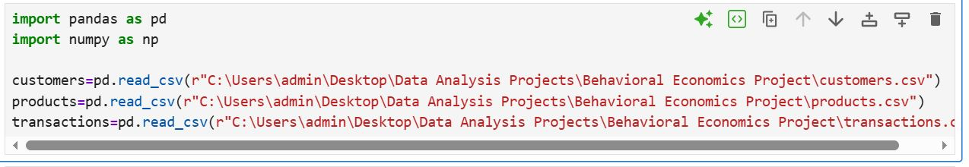

3.2 Dataset Inspection
The imported datasets were initially examined to understand their structure and ensure that the data was suitable for further analysis. Each dataset was inspected to determine the number of records, available attributes, data types, descriptive statistics, duplicate entries, and missing values.
The following validation checks were performed for all three datasets:
- Dataset dimensions
- Attribute names
- Summary statistics
- Data types
- Missing value detection
- Duplicate record detection
These preliminary checks confirmed that the datasets were complete and suitable for behavioural analysis.

Dataset Information / .info() Output

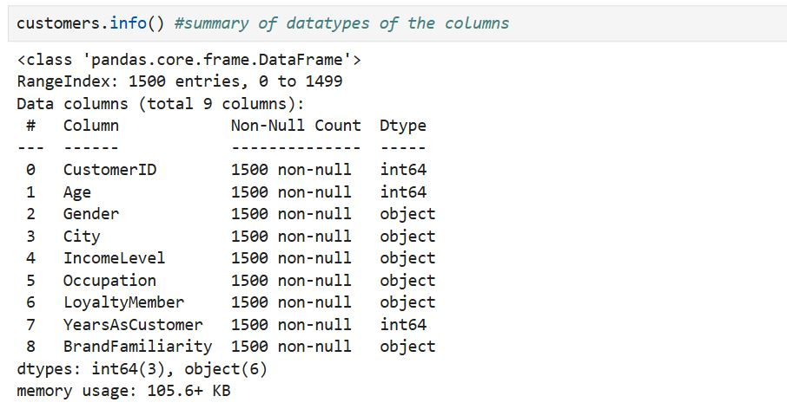

3.3 Feature Engineering
To enable meaningful behavioural analysis, several additional attributes were derived from the original datasets. These engineered features simplified customer segmentation and supported deeper behavioural investigations during the SQL analysis phase.

3.3.1 Customer Age Segmentation
Customers were categorized into behavioural age groups instead of using raw numerical ages. This enabled comparison of purchasing behaviour across meaningful demographic segments.
The following customer segments were created:
- Gen Z
- Young Adult
- Mid Career
- Mature Adults
- Seniors

Age Group Feature Engineering Code and Output
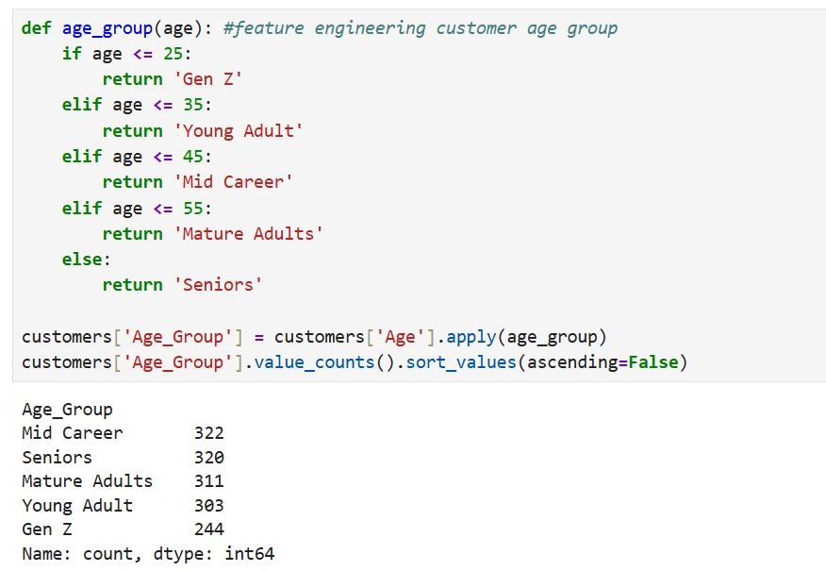

3.3.2 Customer Tenure Classification
Years of customer association were grouped into meaningful tenure categories to analyse how customer experience influences behavioural responsiveness.
The customer tenure categories included:
- New Customer
- 1–2 Years
- 3–5 Years
- 6–10 Years
- 10+ Years
These categories later supported the analysis of behavioural nudges across different stages of customer loyalty.

Years as Customer Range Creation

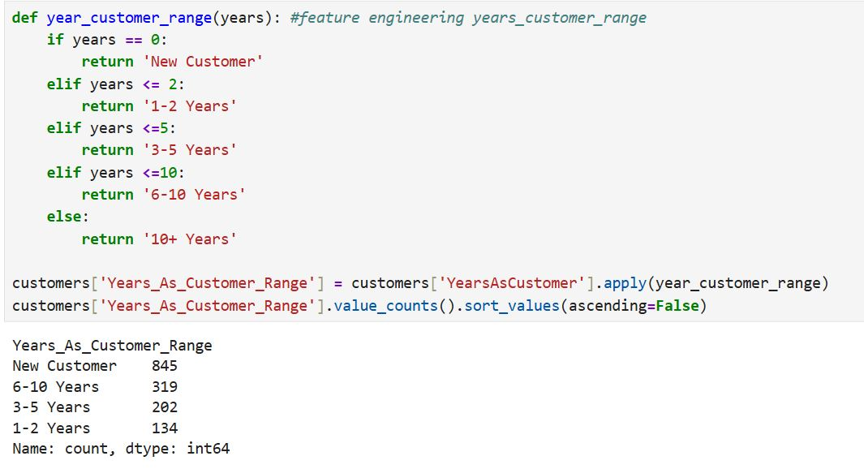

3.3.3 Discount Percentage Calculation
Instead of relying solely on product prices, a new feature representing discount percentage was calculated using the original and current product prices.
This variable enabled subsequent investigations into pricing psychology, discount responsiveness, and price anchoring effects.

Discount Percentage Calculation
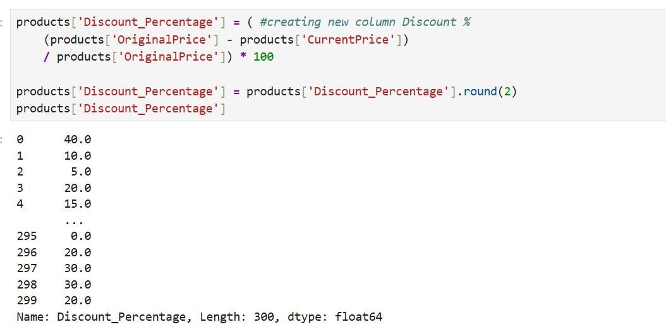

3.3.4 Decision Speed Classification
Customer decision-making time was converted into categorical behavioural segments to simplify purchasing behaviour analysis.
Three decision speed categories were defined:
- Fast
- Medium
- Slow
This classification later enabled comparison between urgency-based marketing interventions and purchasing speed.

Decision Speed Feature Engineering

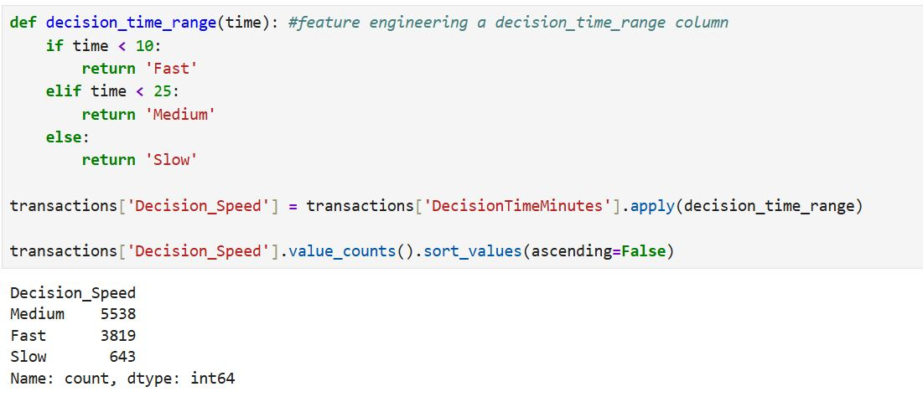

3.4 Dataset Integration
Following feature engineering, the three independent datasets were merged into a unified behavioural dataset using customer and product identifiers.
The merged dataset combined customer demographics, purchasing behaviour, transaction details, pricing information, behavioural nudges, and engineered variables into a single analytical table.
This consolidated dataset served as the primary data source for all subsequent SQL investigations and Power BI visualizations.

Dataset Merge Operation

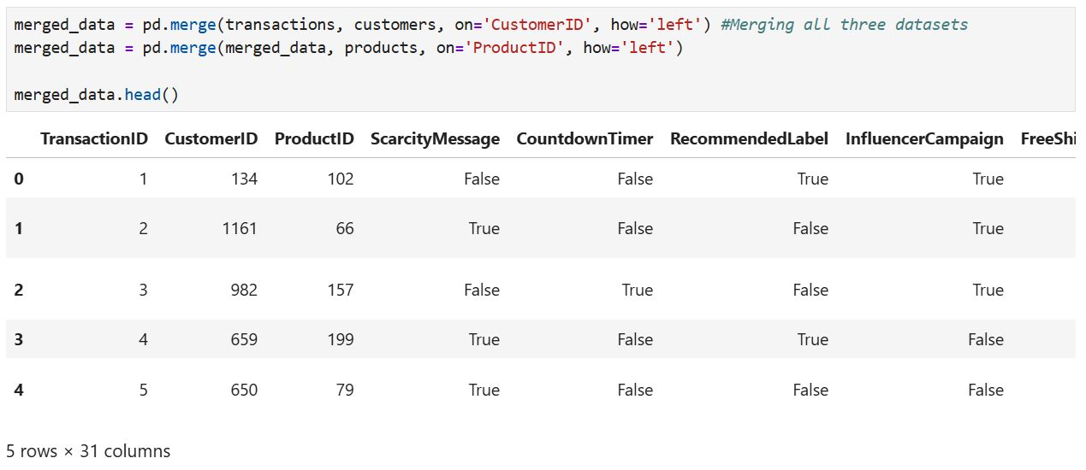

3.5 Exporting the Analytical Dataset
After completing preprocessing and feature engineering, the final behavioural dataset was exported as a CSV file for import into MySQL.
This dataset contained all original variables together with the engineered behavioural features required for advanced SQL analysis.

3.6 Preliminary Behavioural Exploration
Before performing detailed SQL-based investigations, an initial exploratory analysis was conducted using Python to understand broad behavioural trends within the dataset.
Several behavioural relationships were explored, including:
- Purchase trends across different age groups
- Gender-wise purchase behaviour
- Customer tenure and purchasing patterns
- Product category performance
- Discount responsiveness
- Brand familiarity and purchase behaviour
- Effect of behavioural nudges such as scarcity messages, countdown timers, recommendation labels, influencer campaigns, trending badges, and free shipping
- Decision-making speed and purchase conversion
- Interaction between behavioural nudges and customer segments
These preliminary observations helped identify promising behavioural patterns and guided the formulation of more detailed SQL investigations presented in the following chapters.

Sample Exploratory Analysis Output

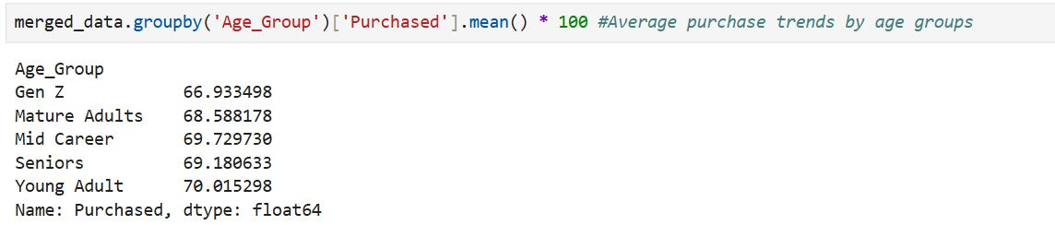

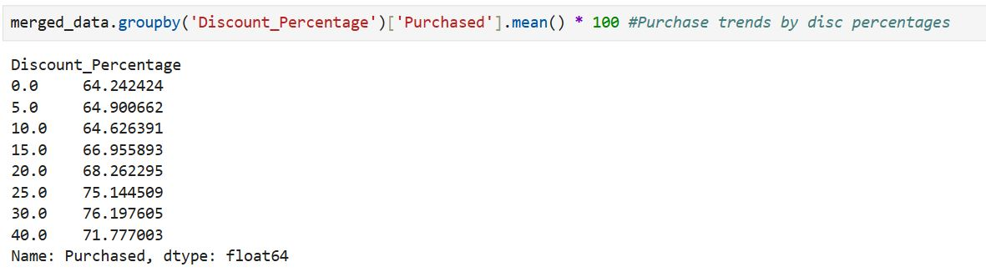

CHAPTER 4

Behavioural Investigation using SQL

4.1 Introduction
After completing data preparation and feature engineering in Python, SQL was used as the primary analytical tool to investigate consumer purchasing behaviour and evaluate the effectiveness of behavioural marketing interventions.
Rather than limiting the analysis to descriptive statistics, this phase focused on testing behavioural hypotheses inspired by principles of consumer psychology. Using SQL, customers were analysed across multiple demographic groups, purchasing behaviours, psychological nudges, and marketing conditions to identify patterns that influence conversion rates and decision-making.
Advanced SQL techniques including Common Table Expressions (CTEs), Window Functions, CASE expressions, Views, Stored Procedures, User Defined Functions, and Indexing were implemented to perform efficient behavioural analysis and generate business insights.

4.2 Consumer Behaviour Overview
The first stage of analysis established a baseline understanding of customer purchasing behaviour before evaluating behavioural interventions. Various demographic, behavioural and transactional attributes were examined to identify existing trends within the dataset.
The following analyses were performed:
- Overall Conversion Rate
- Average Decision Time of Purchasers vs Non-Purchasers
- Purchase Rate by Product Category
- Purchase Rate by City
- Purchase Rate by Income Level
- Brand Performance Analysis
- Conversion Rate by Decision Speed
- Brand Familiarity Analysis
- Loyalty Member Behaviour
- Purchase Behaviour across Different Age Groups

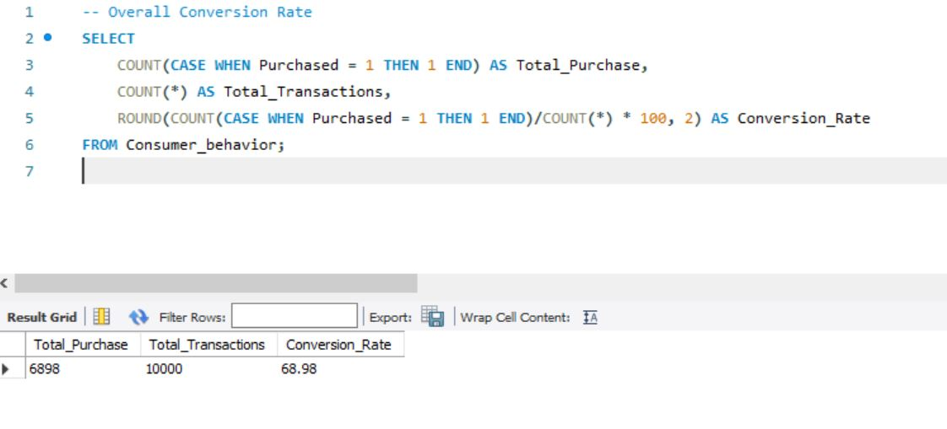Overall Conversion Rate SQL Query + Output
Observation
The overall conversion rate established the baseline purchasing behaviour of consumers and served as the reference point for all subsequent behavioural experiments.

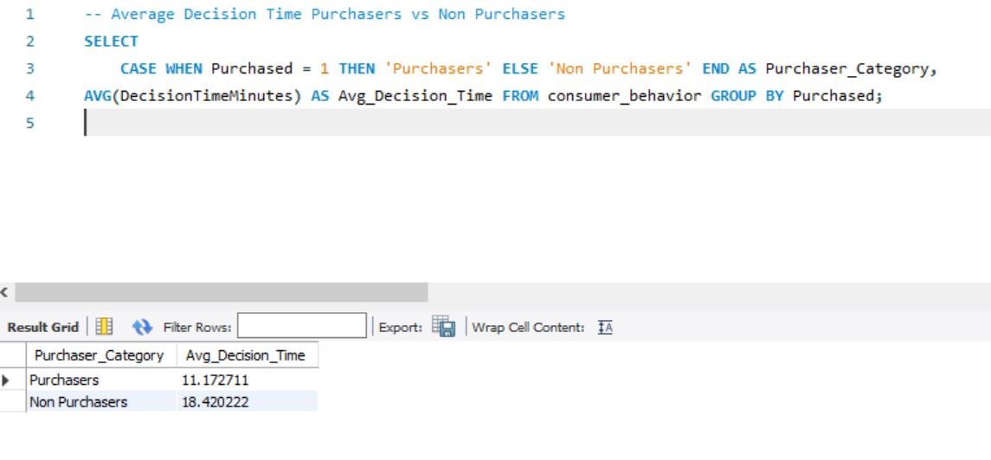Average Decision Time: Purchasers vs Non-Purchasers
Observation
Customers who completed purchases required significantly less decision-making time compared to non-purchasers, indicating a strong relationship between decision speed and purchase likelihood.

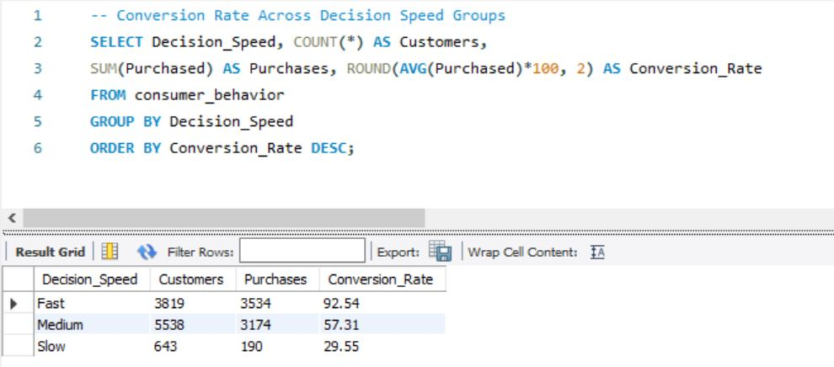Conversion Rate by Decision Speed
Observation
Fast decision-makers recorded the highest conversion rates, while slower decision-makers were considerably less likely to complete purchases. This finding suggests that reducing cognitive effort and accelerating purchase decisions may positively influence conversions.

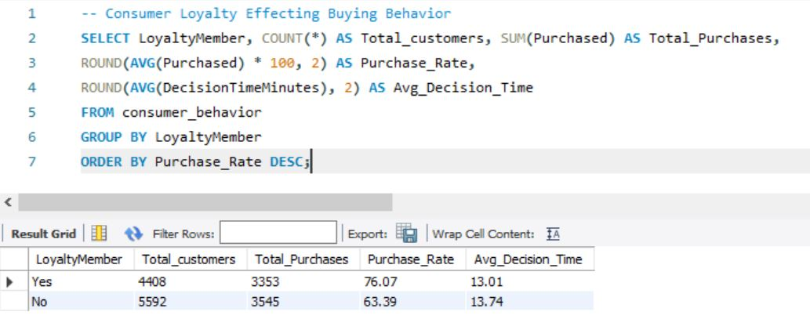Loyalty Member Behaviour
Observation
Loyal customers consistently demonstrated higher purchase rates than non-loyal customers, highlighting the influence of customer loyalty on purchasing decisions.

4.3 Behavioural Psychology Investigation
The primary objective of this investigation was to evaluate the effectiveness of various behavioural nudges commonly used in digital marketing. Each intervention was analysed by comparing an experimental group (customers exposed to the nudge) against a control group (customers not exposed).
The behavioural interventions examined included:
- Scarcity Messaging (Fear of Missing Out)
- Countdown Timer
- Recommended Labels
- Free Shipping
- Trending Badge (Bandwagon Effect)
- Influencer Campaign
For each intervention, purchase rates and average decision times were analysed to determine whether the behavioural cue improved consumer response.

4.3.1 Scarcity Bias (Fear of Missing Out)
Scarcity messaging leverages the psychological tendency of consumers to assign greater value to products perceived as limited or exclusive.
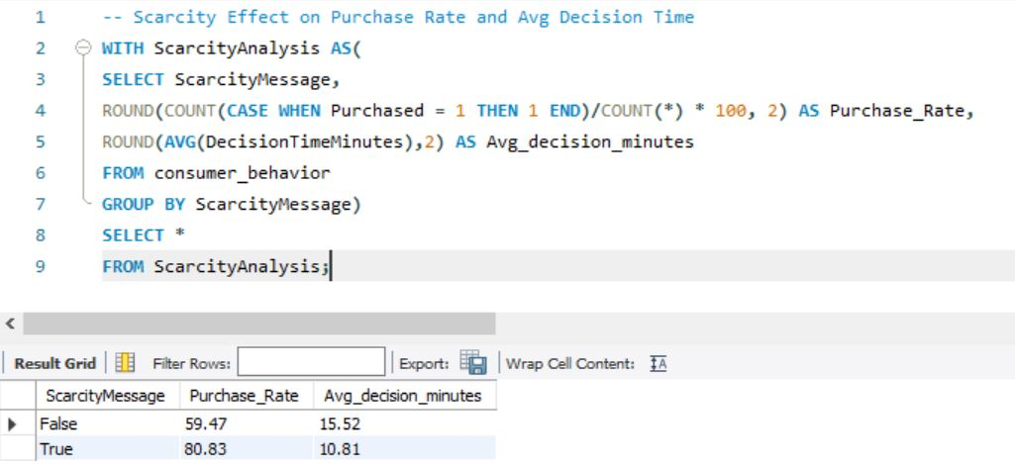Scarcity SQL Query + Result
Observation
Consumers exposed to scarcity messaging exhibited a substantially higher purchase rate while also making decisions more quickly than customers who were not exposed, demonstrating the effectiveness of scarcity-driven marketing.

4.3.2 Countdown Timer
Countdown timers introduce urgency by creating perceived time constraints, encouraging faster decision-making.
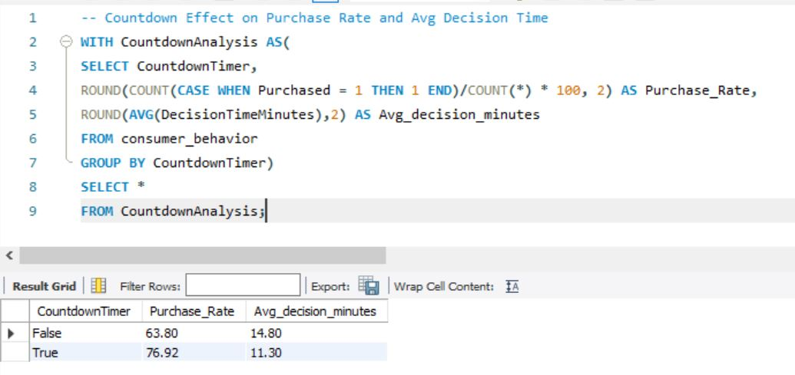Countdown Timer SQL Query + Result
Observation
Exposure to countdown timers increased purchase rates while simultaneously reducing average decision time, supporting the effectiveness of urgency-based marketing strategies.

4.3.3 Recommended Labels
Recommendation labels reduce cognitive effort by signalling products as preferred or popular choices.
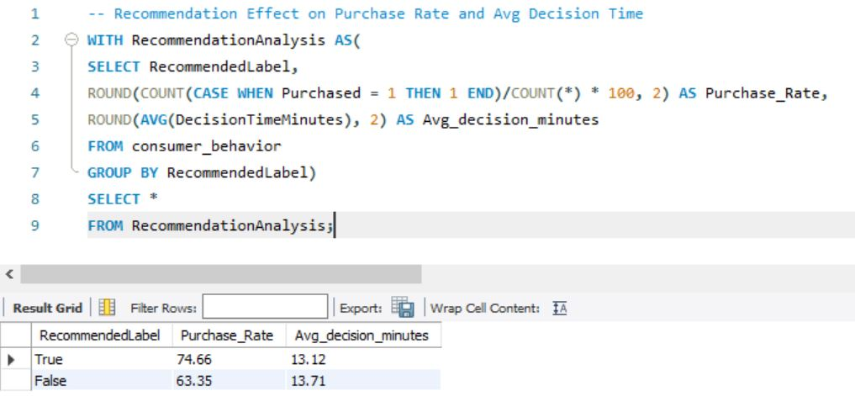Recommended Label SQL Query + Result
Observation
Customers exposed to recommendation labels demonstrated improved purchase rates compared to the control group, indicating that recommendation cues positively influence purchase behaviour.

4.3.4 Free Shipping
Free shipping reduces perceived purchase cost and acts as a strong purchase incentive.
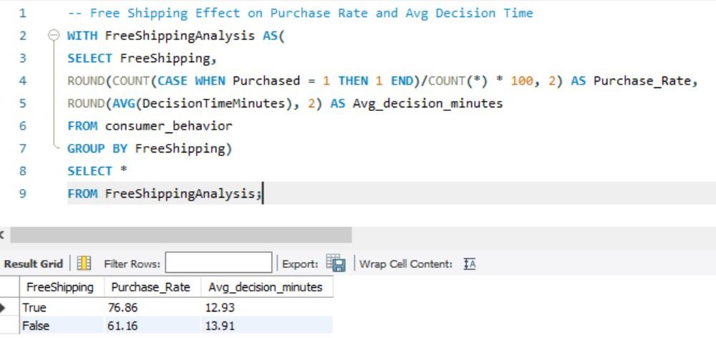Free Shipping SQL Query + Result
Observation
Free shipping produced a noticeable improvement in conversion rates while encouraging faster purchase decisions, making it one of the stronger behavioural interventions evaluated.

4.3.5 Social Proof (Trending Badge & Influencer Campaign)
Social proof influences purchasing decisions by signalling popularity or endorsement through influencers and trending indicators.

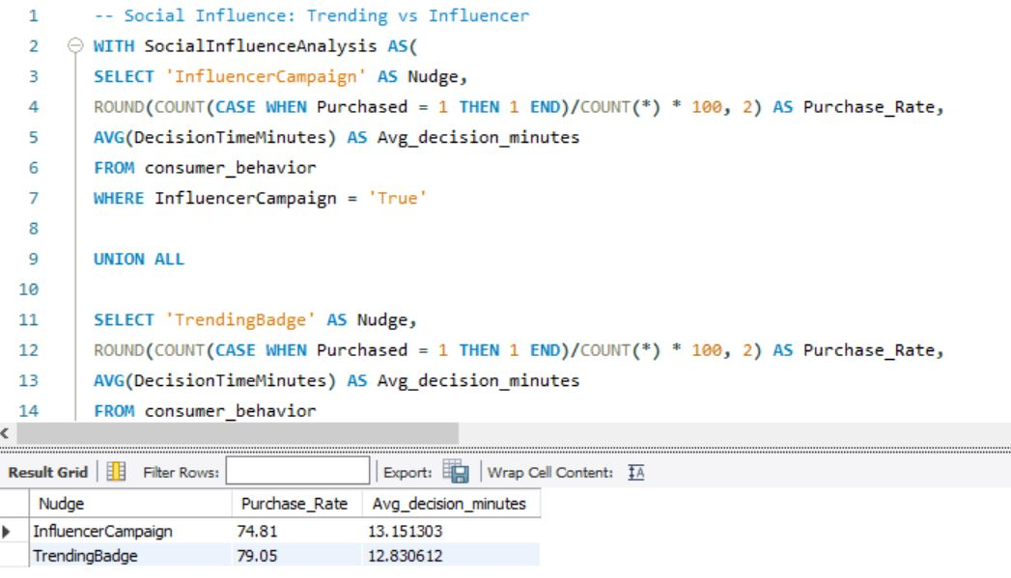
Trending Badge & Influencer SQL Query + Results
Observation
Both interventions positively influenced purchasing behaviour, although the Trending Badge demonstrated stronger behavioural impact than Influencer Campaigns within the analysed dataset.

4.4 Comparative Nudge Performance
After analysing each behavioural intervention independently, all six psychological nudges were consolidated into a unified comparative framework using Common Table Expressions (CTEs) and SQL ranking functions.
Conversion Lift was calculated by comparing the purchase rates of exposed customers (experimental group) against non-exposed customers (control group). This enabled objective ranking of each intervention based on its behavioural effectiveness.
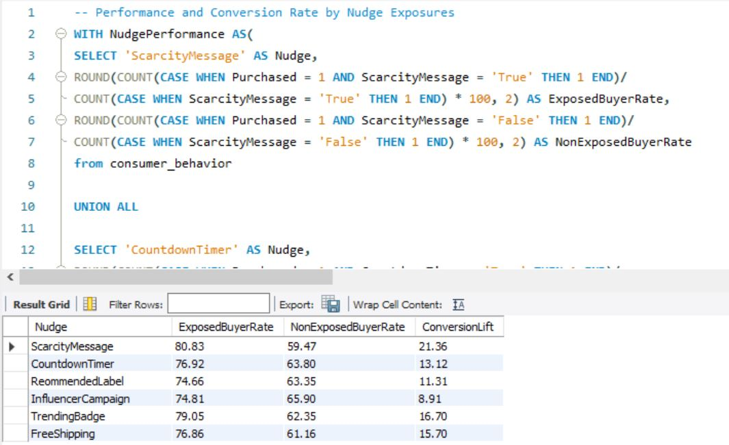Overall Nudge Performance Query
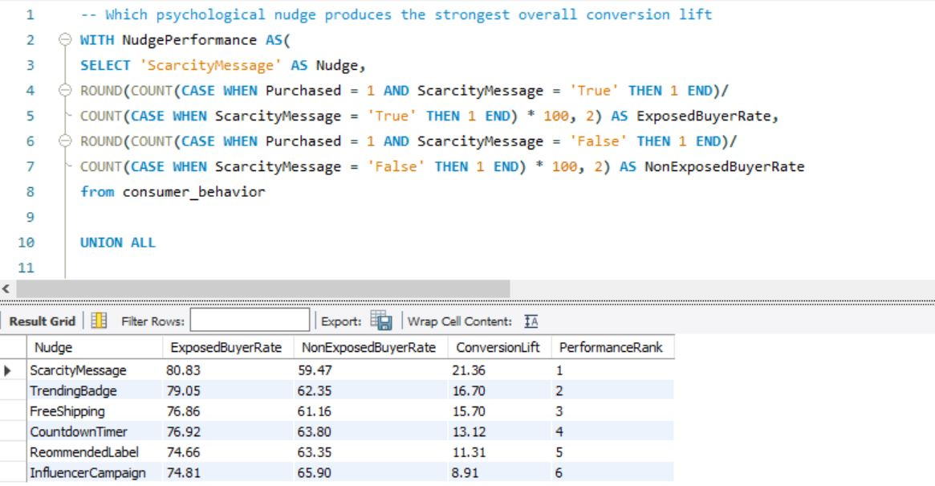Ranked Nudge Performance Results
Observation
Scarcity Messaging produced the highest overall conversion lift, followed by Trending Badge and Free Shipping. These findings indicate that urgency-based and social proof interventions generated stronger behavioural influence than recommendation labels or influencer campaigns.

4.5 Customer Segment Behaviour Analysis
Consumer responses to behavioural interventions were further analysed across different customer segments to determine whether specific groups were more susceptible to particular psychological nudges.
Segment-wise analyses included:
- Age Groups
- Loyalty Members
- Income Levels
- Customer Tenure
- Product Categories
This approach enabled more targeted behavioural insights by identifying which customer segments responded most strongly to different marketing interventions.

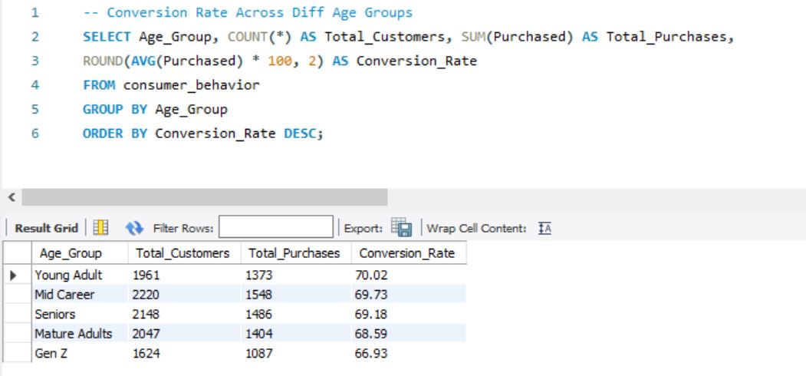Age Group Behaviour Analysis
Observation
Behavioural responses varied across age groups, demonstrating that psychological interventions do not affect all customer segments equally.

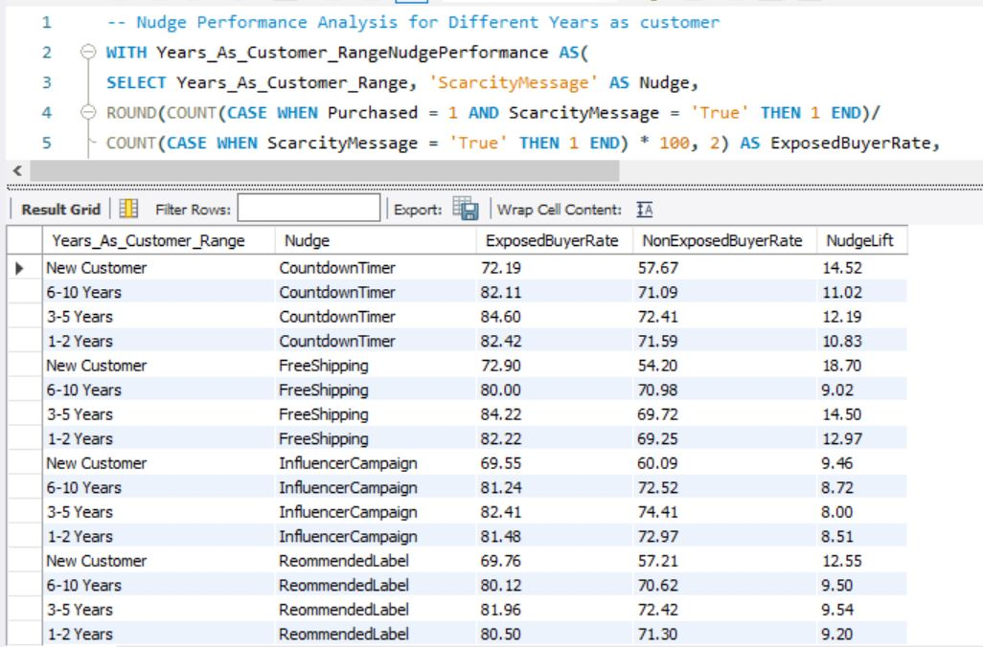Customer Tenure Analysis
Observation
The effectiveness of behavioural nudges changed according to customer tenure, suggesting that marketing strategies should be adapted for new and long-term customers separately.

4.6 Pricing Behaviour Analysis
Discount sensitivity was analysed to determine how increasing discount percentages influenced purchase probability.
Window Functions, including the LAG() function, were used to calculate incremental conversion gains across different discount ranges.
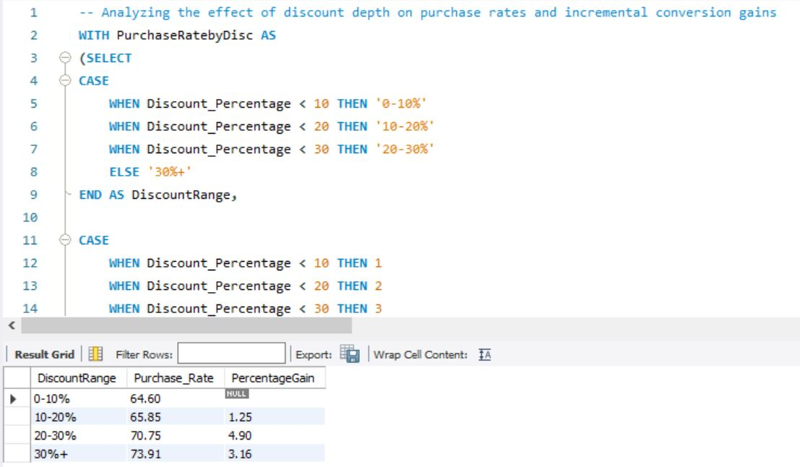Discount Analysis SQL Query
Observation
Purchase rates increased with larger discount percentages; however, the incremental gains varied across discount ranges, indicating diminishing returns beyond certain discount levels.

4.7 Customer Segmentation
Window Functions (NTILE()) were used to classify purchasers into three spending segments:
- Budget Buyers
- Value Buyers
- Premium Buyers
Each segment was analysed based on average purchase value, average decision time and discount sensitivity.
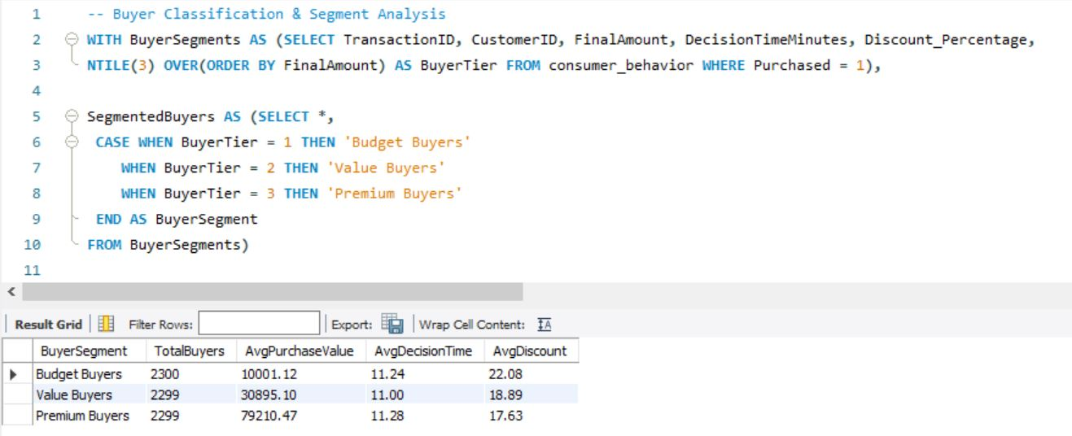Buyer Segmentation Query + Output
Observation
Customer segmentation highlighted meaningful differences in purchasing behaviour across spending groups, providing valuable insights for targeted pricing and marketing strategies.

4.8 SQL Optimization and Reusability
To improve efficiency and demonstrate database engineering practices, additional SQL objects were developed.
These included:
- A reusable SQL View for behavioural performance analysis.
- A User Defined Function for discount categorisation.
- Stored Procedures for analysing scarcity and discount response across customer segments.
- An Index to improve query performance on frequently analysed behavioural variables.
View Creation
CREATE VIEW NudgeConversionPerformance AS
WITH NudgePerformance AS(
SELECT 'ScarcityMessage' AS Nudge,
ROUND(COUNT(CASE WHEN Purchased = 1 AND ScarcityMessage = 'True' THEN 1 END)/
COUNT(CASE WHEN ScarcityMessage = 'True' THEN 1 END) * 100, 2) AS ExposedBuyerRate,
ROUND(COUNT(CASE WHEN Purchased = 1 AND ScarcityMessage = 'False' THEN 1 END)/
COUNT(CASE WHEN ScarcityMessage = 'False' THEN 1 END) * 100, 2) AS NonExposedBuyerRate
from consumer_behavior

UNION ALL

SELECT 'CountdownTimer' AS Nudge,
ROUND(COUNT(CASE WHEN Purchased = 1 AND CountdownTimer = 'True' THEN 1 END)/
COUNT(CASE WHEN CountdownTimer = 'True' THEN 1 END) * 100, 2) AS ExposedBuyerRate,
ROUND(COUNT(CASE WHEN Purchased = 1 AND CountdownTimer = 'False' THEN 1 END)/
COUNT(CASE WHEN CountdownTimer = 'False' THEN 1 END) * 100, 2) AS NonExposedBuyerRate
from consumer_behavior

UNION ALL

SELECT 'ReommendedLabel' AS Nudge,
ROUND(COUNT(CASE WHEN Purchased = 1 AND RecommendedLabel = 'True' THEN 1 END)/
COUNT(CASE WHEN RecommendedLabel = 'True' THEN 1 END) * 100, 2) AS ExposedBuyerRate,
ROUND(COUNT(CASE WHEN Purchased = 1 AND RecommendedLabel = 'False' THEN 1 END)/
COUNT(CASE WHEN RecommendedLabel = 'False' THEN 1 END) * 100, 2) AS NonExposedBuyerRate
from consumer_behavior

UNION ALL

SELECT 'InfluencerCampaign' AS Nudge,
ROUND(COUNT(CASE WHEN Purchased = 1 AND InfluencerCampaign = 'True' THEN 1 END)/
COUNT(CASE WHEN InfluencerCampaign = 'True' THEN 1 END) * 100, 2) AS ExposedBuyerRate,
ROUND(COUNT(CASE WHEN Purchased = 1 AND InfluencerCampaign = 'False' THEN 1 END)/
COUNT(CASE WHEN InfluencerCampaign = 'False' THEN 1 END) * 100, 2) AS NonExposedBuyerRate
from consumer_behavior

UNION ALL

SELECT 'TrendingBadge' AS Nudge,
ROUND(COUNT(CASE WHEN Purchased = 1 AND TrendingBadge = 'True' THEN 1 END)/
COUNT(CASE WHEN TrendingBadge = 'True' THEN 1 END) * 100, 2) AS ExposedBuyerRate,
ROUND(COUNT(CASE WHEN Purchased = 1 AND TrendingBadge = 'False' THEN 1 END)/
COUNT(CASE WHEN TrendingBadge = 'False' THEN 1 END) * 100, 2) AS NonExposedBuyerRate
from consumer_behavior

UNION ALL

SELECT 'FreeShipping' AS Nudge,
ROUND(COUNT(CASE WHEN Purchased = 1 AND FreeShipping = 'True' THEN 1 END)/
COUNT(CASE WHEN FreeShipping = 'True' THEN 1 END) * 100, 2) AS ExposedBuyerRate,
ROUND(COUNT(CASE WHEN Purchased = 1 AND FreeShipping = 'False' THEN 1 END)/
COUNT(CASE WHEN FreeShipping = 'False' THEN 1 END) * 100, 2) AS NonExposedBuyerRate
from consumer_behavior),

Ranked AS (SELECT Nudge, ExposedBuyerRate, NonExposedBuyerRate,
ExposedBuyerRate - NonExposedBuyerRate AS ConversionLift,
RANK() OVER(ORDER BY ExposedBuyerRate - NonExposedBuyerRate DESC) AS PerformanceRank
FROM NudgePerformance)

SELECT * FROM Ranked;
Stored Procedure
DELIMITER //
CREATE PROCEDURE AnalyzeScarcityByAge(
IN selected_age_group VARCHAR(50))
BEGIN
SELECT Age_Group, ROUND(COUNT(CASE WHEN Purchased = 1 AND ScarcityMessage = 'True' THEN 1 END) * 100.0 /
COUNT(CASE WHEN ScarcityMessage = 'True' THEN 1 END), 2) AS ScarcityPurchaseRate,
ROUND(COUNT(CASE WHEN Purchased = 1 AND ScarcityMessage = 'False' THEN 1 END) * 100/
COUNT(CASE WHEN ScarcityMessage = 'False' THEN 1 END), 2 ) AS NoScarcityPurchaseRate
FROM consumer_behavior
WHERE Age_Group = selected_age_group
GROUP BY Age_Group;
END //
DELIMITER ;
User Defined Function
-- Creating Discount category function
DELIMITER //

CREATE FUNCTION DiscountCategory(discount decimal(6,2))
RETURNS VARCHAR(20)
DETERMINISTIC

BEGIN
DECLARE category VARCHAR(20);

SET category = CASE
WHEN discount < 10 THEN 'Low Discount'
WHEN discount < 20 THEN 'Moderate Discount'
ELSE 'High Discount'
END;
RETURN category;
END//
DELIMITER ;
Index Creation
-- Creating Index on Scarcity Message and Purchase
CREATE INDEX idx_scarcity_purchase
ON consumer_behavior(ScarcityMessage, Purchased);
These database objects improved query modularity, reduced code repetition, and demonstrated the application of advanced SQL concepts beyond analytical querying.

4.9 Chapter Summary
SQL formed the core analytical engine of this project by transforming prepared data into actionable behavioural insights. Through advanced querying techniques, behavioural experiments, customer segmentation, conversion lift analysis, and psychological intervention evaluation, this phase identified the factors that most strongly influenced consumer purchasing behaviour. The insights generated during this stage provided the foundation for the interactive Power BI dashboards presented in the following chapter.

CHAPTER 5

Interactive Dashboard Development using Power BI

5.1 Introduction
Following the completion of behavioural analysis in Python and SQL, Microsoft Power BI was used to transform the analytical findings into interactive dashboards. The objective was to present complex behavioural insights in a visually intuitive format, enabling users to quickly identify purchasing trends, evaluate marketing interventions, and compare customer responses across multiple dimensions.
The dashboards were designed to communicate key business insights rather than perform additional analysis, with each visual directly representing findings derived from the SQL investigation.

5.2 Dashboard Design
The dashboard was organised into three analytical sections, each addressing a different aspect of consumer purchasing behaviour.

Dashboard 1 – Behavioural Overview: Consumer Decisions
This dashboard provides an overview of the overall purchasing behaviour of consumers. Key performance indicators (KPIs) and summary visualisations were included to present the baseline characteristics of the dataset.
The dashboard includes:
- Total Transactions
- Overall Conversion Rate
- Average Decision Time
- Average Purchase Value
- Conversion Rate by Decision Speed
- Average Decision Time by Age Group
- Average Decision Time: Purchasers vs Non-Purchasers
- Conversion Rate by Age Group
- Conversion Rate by Income Level
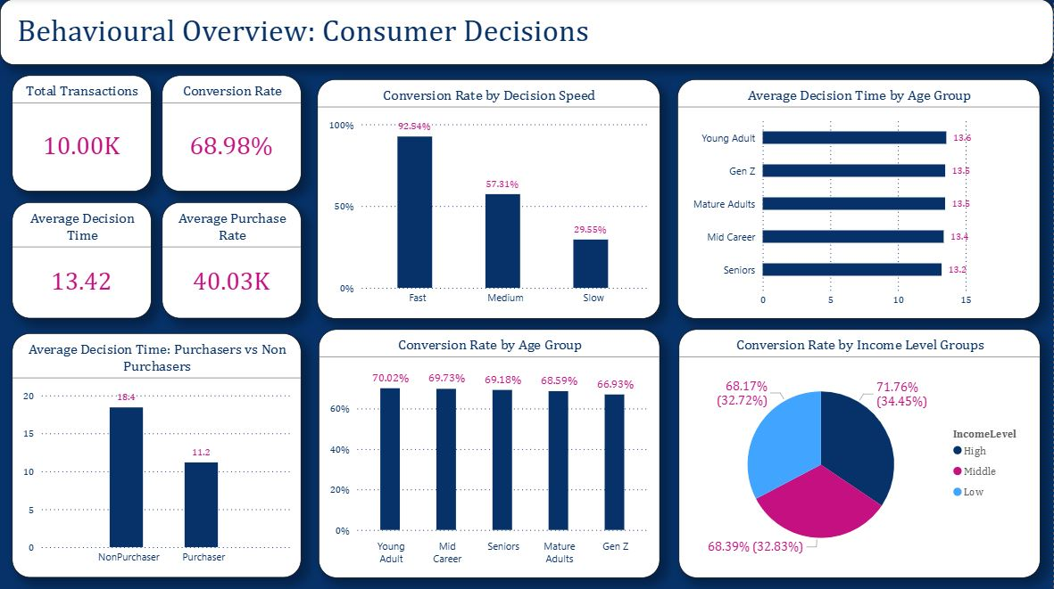

Dashboard 2 – Marketing Nudge Performance
The second dashboard focuses on evaluating the effectiveness of behavioural marketing interventions. It compares the performance of multiple psychological nudges and highlights which interventions generated the highest conversion improvements.
The dashboard includes:
- Best Performing Nudge
- Highest Conversion Lift
- Decision Time Reduction
- Conversion Rate by Nudge
- Conversion Lift Comparison
- Highest Nudge Lift by Customer Tenure
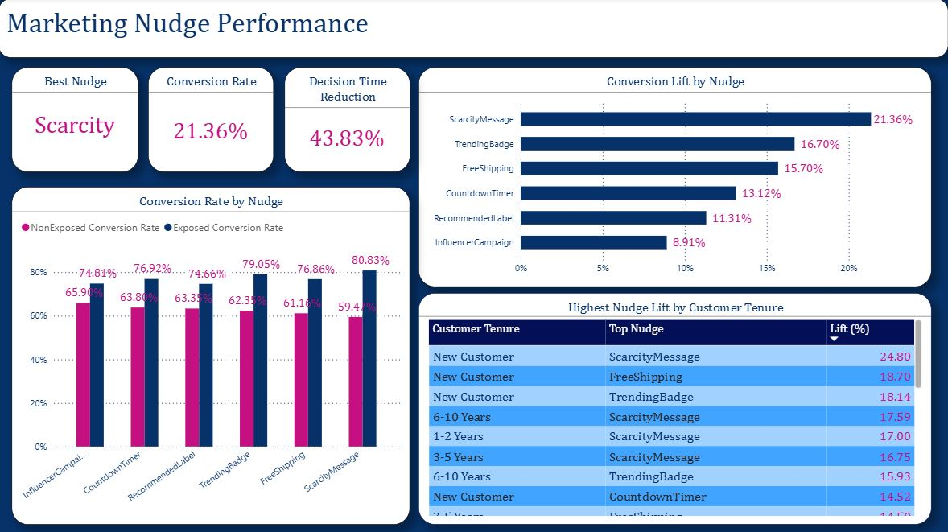

Dashboard 3 – Customer Purchase Behaviour
The final dashboard presents customer response patterns under different purchasing conditions. It highlights behavioural differences across customer groups and examines the relationship between pricing strategies, psychological interventions, and purchasing behaviour.
The dashboard includes:
- Loyalty vs Non-Loyal Customers under Free Shipping
- Decision Time Reduction and Conversion Lift by Nudge
- Purchase Rate by Discount Percentage
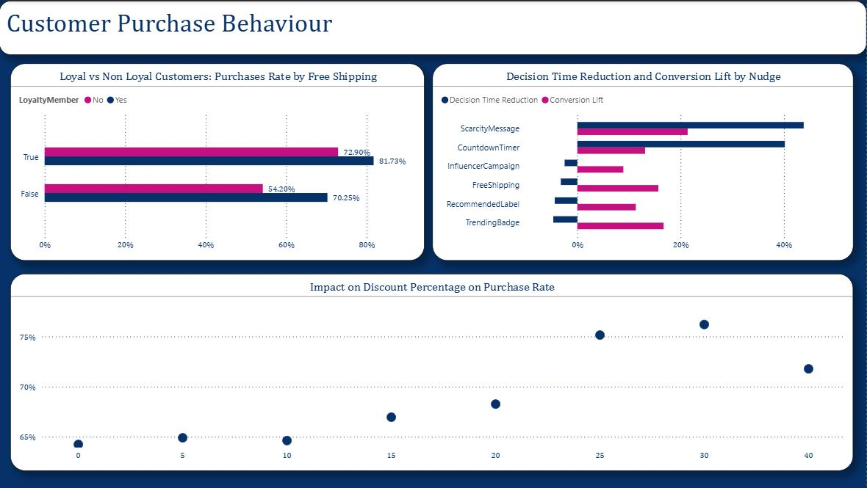

5.3 Key Insights from the Dashboard
The dashboards successfully translated the analytical findings into an interactive business intelligence solution. Several important insights were immediately visible:
- Scarcity messaging emerged as the most effective behavioural intervention, producing the highest conversion lift.
- Customers exposed to psychological nudges generally made purchasing decisions more quickly than non-exposed customers.
- Free shipping had a stronger impact on non-loyal customers, indicating its effectiveness in attracting new or less committed buyers.
- Higher discount percentages generally resulted in increased purchase rates, although the relationship was not perfectly linear.
- Customer tenure influenced the effectiveness of behavioural nudges, suggesting opportunities for more targeted marketing strategies.

5.4 Chapter Summary
Power BI served as the visualization and decision-support layer of the project by transforming SQL-based behavioural analyses into interactive dashboards. The dashboards provide a concise yet comprehensive view of consumer purchasing behaviour, psychological marketing interventions, and customer response patterns, enabling business stakeholders to interpret analytical findings quickly and support data-driven decision-making.

CHAPTER 6

Behavioural Insights & Key Findings

6.1 Overall Consumer Behaviour
Analysis of 10,000 consumer transactions revealed an overall conversion rate of 68.98%, indicating that nearly seven out of every ten visitors completed a purchase. A clear behavioural difference was observed between purchasers and non-purchasers.
Purchasers completed their buying decisions in an average of 11.18 minutes, whereas non-purchasers required approximately 18.40 minutes, representing nearly a 65% longer decision-making process. This suggests that prolonged cognitive evaluation increases purchase abandonment, whereas quicker decisions are more strongly associated with successful conversions.

6.2 Decision Speed as a Behavioural Predictor
Decision speed emerged as one of the strongest indicators of purchasing behaviour.
Analysis showed:
Decision Speed | Conversion Rate
Fast | 92.54%
Medium | 57.31%
Slow | 29.55%
Customers making rapid decisions were more than three times as likely to purchase compared to slow decision makers.
This observation strongly supports behavioural psychology research suggesting that reducing cognitive friction and decision fatigue substantially improves purchasing outcomes.

6.3 Demographic Behaviour Patterns
Behavioural differences across demographic groups were relatively modest, suggesting that psychological behaviour influences purchasing decisions more strongly than demographic characteristics alone.
Key observations include:
- Young Adults achieved the highest conversion rate (70.02%).
- Gen Z recorded the lowest conversion rate (66.93%).
- Middle-income consumers demonstrated the highest purchase rate (68.39%), closely followed by high-income consumers (68.17%).
- Decision times remained remarkably similar across all age groups (approximately 13–14 minutes), indicating that age alone had limited influence on purchasing speed.
These findings suggest that demographic segmentation should complement rather than replace behavioural targeting strategies.

6.4 Consumer Loyalty and Brand Familiarity
Customer familiarity significantly influenced purchasing behaviour.
Customers with:
- High Brand Familiarity achieved a 76.77% conversion rate
- Medium Familiarity recorded 69.06%
- Low Familiarity achieved only 62.76%
Similarly, loyalty members demonstrated:
- 76.07% purchase rate
- Average decision time of 13.01 minutes
compared with
- 63.39% purchase rate
- 13.74 minute average decision time among non-members.
These findings indicate that consumer trust substantially reduces purchase hesitation and increases buying confidence.

6.5 Behavioural Impact of Psychological Nudges
The core objective of this study was to evaluate whether behavioural interventions based on cognitive psychology could influence purchasing decisions.
To measure this objectively, each nudge was analysed using a control group (customers not exposed) and an experimental group (customers exposed). Conversion Lift was then calculated as:
Conversion Lift = Exposed Conversion Rate − Non-Exposed Conversion Rate
This methodology isolates the behavioural influence of each intervention independent of the overall purchase rate.

6.6 Scarcity Effect (Fear of Missing Out – FOMO)
Among all behavioural interventions, Scarcity Messaging produced the strongest behavioural response.
Customers exposed to scarcity cues achieved:
- 80.83% conversion rate
compared to
- 59.47% among customers who were not exposed.
This represents a remarkable

21.36 percentage point Conversion Lift
—the highest observed throughout the study.
Additionally,
- Average decision time decreased from 15.52 minutes
- to 10.81 minutes
representing approximately 30.35% faster purchasing decisions.
These findings strongly support the behavioural principle of Loss Aversion, where consumers act more quickly when they perceive potential scarcity or limited availability.

6.7 Social Proof and Bandwagon Behaviour
Social influence interventions also produced substantial improvements in purchasing behaviour.

Trending Badge
- Conversion Rate: 79.05%
- Conversion Lift: 16.70%

Influencer Campaign
- Conversion Rate: 74.81%
- Conversion Lift: 8.91%
Interestingly, simple indications that a product was "Trending" produced almost double the behavioural impact of influencer endorsements.
This suggests that collective behavioural validation (Bandwagon Effect) was more persuasive than authority-based influence within this dataset.

6.8 Free Shipping as a Behavioural Incentive
Free shipping significantly increased purchasing likelihood.
Customers receiving free shipping converted at:
76.86%
compared with
61.16%
for customers without the incentive.
This generated a
15.70% Conversion Lift
while also reducing average decision time.
The results suggest that consumers perceive shipping charges as a psychological loss, making free shipping an especially effective behavioural incentive.

6.9 Countdown Timer and Urgency
Countdown timers introduced artificial urgency into the purchasing process.
Results showed:
- Exposed Conversion Rate: 76.92%
- Non-Exposed Conversion Rate: 63.80%
- Conversion Lift: 13.12%
For customers already making fast purchasing decisions, countdown timers produced an additional 15.77% behavioural lift, demonstrating that urgency cues amplify already existing buying intentions.

6.10 Recommendation Labels
Recommendation labels also improved purchasing behaviour.
Customers exposed to recommended product labels achieved:
- 74.66% conversion rate
compared with
- 63.35%
for customers who did not receive recommendations.
Although the behavioural impact (11.31% lift) was smaller than scarcity or free shipping, recommendation labels effectively reduced decision uncertainty by acting as heuristic shortcuts during evaluation.

6.11 Ranking Behavioural Nudges
Ranking all interventions by overall behavioural effectiveness produced the following order:
Rank | Behavioural Intervention | Conversion Lift
1 | Scarcity Message | 21.36%
2 | Trending Badge | 16.70%
3 | Free Shipping | 15.70%
4 | Countdown Timer | 13.12%
5 | Recommended Label | 11.31%
6 | Influencer Campaign | 8.91%
These results indicate that FOMO-based interventions consistently outperformed authority-based or informational nudges, highlighting the strong influence of perceived scarcity on consumer decision-making.

6.12 Customer Segmentation Findings
Behavioural responses varied across different customer segments.

Age Groups
Senior customers demonstrated the highest responsiveness to scarcity messaging, generating approximately 22.76% conversion lift, while Young Adults showed the lowest relative improvement.

Loyalty
Free shipping produced a stronger behavioural response among non-loyal customers, generating approximately 18.70% conversion lift, compared with 11.40% among loyalty members.
This indicates that free shipping is more effective as a customer acquisition strategy than as a loyalty incentive.

Customer Tenure
Analysis across customer tenure groups revealed that Scarcity Messaging consistently remained the highest-performing intervention, particularly among newer customers.

6.13 Pricing Psychology
Purchase behaviour increased with discount depth.
Purchase Rates were:
Discount | Purchase Rate
0–10% | 64.60%
10–20% | 65.95%
20–30% | 70.75%
30%+ | 73.91%
The largest behavioural improvement occurred between the 10–20% and 20–30% discount ranges, suggesting that consumers perceive discounts beyond approximately 20% as substantially more valuable.
Among income groups, the Middle Income segment exhibited the greatest responsiveness to discount-based incentives.

6.14 Overall Behavioural Conclusions
The findings demonstrate that psychological variables consistently exerted greater influence on purchasing behaviour than demographic characteristics.
Behavioural interventions that leveraged cognitive biases—including Fear of Missing Out (Scarcity Effect), Social Proof (Bandwagon Effect), Loss Aversion (Free Shipping) and Urgency (Countdown Timers)—produced measurable improvements in both conversion rates and decision speed.
The study further shows that combining behavioural psychology with data analytics enables organisations to move beyond descriptive reporting toward evidence-based behavioural decision making. These insights can support the design of more effective marketing strategies, personalized customer experiences, and higher conversion outcomes

CHAPTER 7

Recommendations
The findings of this study demonstrate that consumer purchasing behaviour is significantly influenced by behavioural psychology principles rather than demographic characteristics alone. Based on the analytical results obtained through Python, SQL, and Power BI, the following recommendations are proposed for improving marketing effectiveness and customer conversion rates.

8.1 Prioritize Scarcity-Based Marketing
Scarcity messaging consistently emerged as the most effective behavioural intervention, generating the highest conversion lift (21.36%) while also reducing customer decision time by approximately 43.8%.
Businesses should therefore incorporate limited-time offers, low-stock notifications, exclusive deals, and urgency-driven messaging into product pages and promotional campaigns. Such interventions leverage the psychological principle of Fear of Missing Out (FOMO), encouraging quicker purchasing decisions.

8.2 Utilize Social Proof Strategically
Among social proof interventions, Trending Badges significantly outperformed Influencer Campaigns in improving purchase conversion.
Instead of relying solely on influencer marketing, businesses should prominently display indicators such as:
- Trending Products
- Best Sellers
- Most Purchased Items
- Popular This Week
These cues reinforce the Bandwagon Effect, increasing consumer confidence by highlighting collective purchasing behaviour.

8.3 Offer Free Shipping as a Customer Acquisition Strategy
The analysis revealed that free shipping generated substantially higher conversion improvements among non-loyal customers than among existing loyalty members.
Organizations should therefore prioritize free-shipping incentives for:
- First-time customers
- Guest users
- New customer acquisition campaigns
- Abandoned cart recovery campaigns
This strategy is likely to improve customer acquisition while reducing perceived purchase barriers.

8.4 Reduce Decision Friction
Customers who completed purchases generally required considerably less decision time than non-purchasers.
To minimize cognitive overload and decision fatigue, businesses should simplify the purchasing journey by:
- Reducing unnecessary checkout steps
- Presenting clear product information
- Highlighting recommended products
- Improving website navigation
- Displaying trust signals such as ratings and reviews
A streamlined buying experience can significantly improve conversion rates.

8.5 Personalize Marketing Based on Customer Segments
The behavioural analysis demonstrated that customer groups respond differently to various psychological interventions.
Instead of applying identical marketing strategies to all users, organizations should implement targeted campaigns based on customer characteristics such as:
- Customer tenure
- Loyalty status
- Income segment
- Previous purchasing behaviour
Segment-specific marketing enables more effective allocation of promotional resources while improving customer engagement.

8.6 Optimize Discount Strategies
Increasing discount percentages generally resulted in higher purchase rates, with the most significant improvement observed beyond the 20% discount range.
Businesses should therefore evaluate promotional pricing carefully and reserve higher discount levels for:
- Seasonal campaigns
- Inventory clearance
- Customer acquisition initiatives
- High-competition product categories
At the same time, excessive discounting should be avoided to preserve long-term brand value and profitability.

8.7 Adopt Data-Driven Behavioural Marketing
This study demonstrates the value of integrating behavioural psychology with data analytics.
Organizations should continuously monitor customer behaviour using analytical tools such as Python, SQL, and Power BI to evaluate marketing interventions, measure campaign effectiveness, and identify emerging behavioural patterns. Continuous data-driven experimentation enables evidence-based decision making and more efficient marketing strategies.

8.8 Conduct Continuous Behavioural Experiments
Consumer behaviour evolves over time due to changing market conditions and customer preferences. Organizations should therefore regularly conduct behavioural experiments to evaluate the effectiveness of different nudges, promotional strategies, and user interface designs.
A culture of continuous experimentation will allow businesses to refine marketing approaches and sustain long-term improvements in customer engagement and conversion performance.
CHAPTER 9

Conclusion
This project successfully explored consumer purchasing behaviour through the integration of behavioural psychology and data analytics. Using Python for data preparation and exploratory analysis, SQL for advanced behavioural investigations, and Power BI for interactive visualization, the study examined how psychological marketing interventions influence consumer decision-making and purchase behaviour.
The analysis demonstrated that behavioural nudges such as Scarcity Messages, Trending Badges, Free Shipping, Countdown Timers, Recommendation Labels, and Influencer Campaigns all contributed to improved purchase conversions, with Scarcity Messaging emerging as the most effective intervention. The findings further revealed that behavioural factors had a greater influence on purchasing decisions than demographic characteristics alone, highlighting the importance of cognitive biases such as Fear of Missing Out (FOMO), Social Proof, Loss Aversion, and Urgency in shaping consumer behaviour.
Overall, this study illustrates how combining behavioural psychology with data-driven analysis enables organizations to move beyond descriptive reporting and make evidence-based marketing decisions. The insights generated can support the design of more personalized customer experiences, more effective marketing campaigns, and improved business performance through scientifically informed behavioural strategies.

CHAPTER 8 — AI-POWERED RAG ASSISTANT

8.1 Introduction
The Behavioral Analytics project was further extended by developing an AI-powered Retrieval-Augmented Generation (RAG) assistant. The purpose of this extension was to allow users to ask natural-language questions about the project findings and receive answers based on the project's analytical evidence.
The assistant was designed as an additional interface for exploring the existing project results rather than replacing the Python, SQL, and Power BI analysis.

8.2 Objective
The main objectives of the AI extension were:
- To allow users to query project findings using natural language.
- To retrieve relevant information from the project's knowledge base.
- To generate answers using the retrieved project evidence.
- To reduce unsupported or unrelated AI responses.
- To provide the retrieved evidence along with the generated answer.
- To demonstrate the practical use of Generative AI in a data analytics project.

8.3 RAG Approach
Retrieval-Augmented Generation (RAG) combines information retrieval with Generative AI.
In this project, the process works as follows:
User Question
↓
Question Embedding
↓
Similarity Search
↓
Relevant Project Knowledge
↓
Gemini
↓
AI Answer
The project findings were converted into smaller knowledge chunks and stored in a structured knowledge base.
When a user asks a question, the question is converted into an embedding using the Sentence Transformers all-MiniLM-L6-v2 model. The system then compares the question embedding with the project knowledge embeddings using cosine similarity and retrieves the three most relevant chunks.
These retrieved chunks are provided to Gemini as project evidence. Gemini then generates an answer based on the retrieved information.

8.4 Knowledge Base and Retrieval
The knowledge base contains important findings from the Behavioral Analytics project, including:
- Psychological nudge performance
- Conversion lift results
- Decision-making behaviour
- Customer segmentation findings
- Pricing and discount behaviour
- Behavioural intervention comparisons
For example, when the user asks:
Which psychological nudge performed best?
The retrieval system identifies the project evidence showing that Scarcity Message produced the highest observed conversion lift of 21.36 percentage points.
The retrieved information is then passed to Gemini to generate the final response.

8.5 Gemini Integration
Gemini was used as the Generative AI component of the application.
The model receives:
- The user's question
- The relevant project evidence retrieved by the RAG system
- Instructions to answer only using the provided project evidence
The assistant is also instructed to indicate when sufficient project information is not available.
This helps keep the generated responses focused on the actual findings of the project rather than unrelated general knowledge.

8.6 Streamlit Application
A Streamlit web application was developed as the user interface for the AI assistant.
The application provides:
- Natural-language question input
- AI-generated answers
- Retrieved project evidence
- Session-based conversation history
- A customized interface for the Behavioral Analytics project
The application therefore provides a simple way for users to interact with the project's analytical findings without directly accessing the underlying SQL queries or analysis notebooks.

Application Screenshots
Figure 8.1 – AI Assistant Home Screen
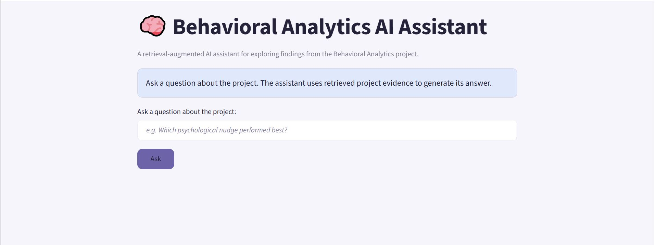

Figure 8.2 – AI Assistant with Retrieved Answer
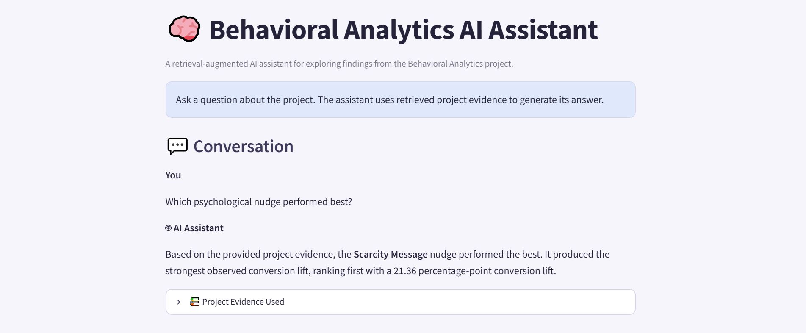

8.7 Testing
The application was tested using both relevant and irrelevant questions.

Relevant Questions
The assistant correctly answered questions such as:
Which psychological nudge performed best?
Scarcity Message produced the strongest observed conversion lift.
What was the conversion lift of the Scarcity Message?
21.36 percentage points.
How did Scarcity Message affect decision-making speed?
The assistant retrieved the relevant decision-behaviour finding and generated a response based on the project evidence.

Out-of-Scope Question
The assistant was also tested with:
What is the capital of France?
Since this information is not part of the project knowledge base, the assistant responded that the project evidence did not provide enough information to answer the question.
This test demonstrated the grounding behaviour of the RAG system.

8.8 Limitations
The AI assistant has the following limitations:
- It can only provide reliable project-specific answers based on the information available in its knowledge base.
- The current retrieval system selects the three most relevant knowledge chunks using semantic similarity.
- The dataset used by the underlying project is synthetic, so the analytical findings should not be interpreted as definitive real-world causal effects.
- The application uses Gemini through an API and therefore requires an API key to operate.

8.9 Conclusion
The RAG extension adds a Generative AI layer to the existing Behavioral Analytics project. By combining Sentence Transformers, semantic retrieval, cosine similarity, Gemini, and Streamlit, the project provides an interactive way to explore analytical findings using natural-language questions.
The extension demonstrates how traditional data analytics can be combined with modern Generative AI techniques to create a more accessible and interactive analytical application.

